# OGC GeoCAT SWG - 20240508

**Attendance:**

1. Byron Cochrane
2. Peter Parslow
3. Chris Little
4. Fabio Vinci
5. Christin Henzen
6. Uwe Voges
7. Rob Atkinson
8. Danny Vandenbroucke
9. Glenn Laughlin
10. Margie Smith

MEETING ACTIONS

@ Byron to look for use case drivers – what our role is and how this group will progress

@ Danny to do the Montreal outreach – to see who else wants to attend the meeting and present

@ Rob to chase up the UNSW venue for the November code sprint

=============================

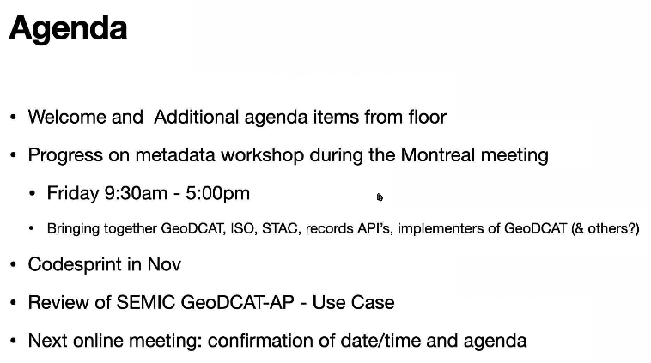

GitHub repo – <https://github.com/opengeospatial/GeoCAT-SWG/issues>

Montreal meeting – 21 July?

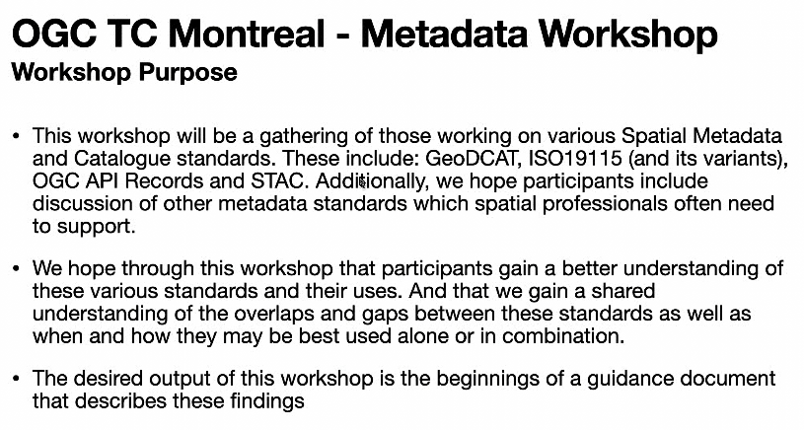

Byron can’t be there, and the time zone is not great (1am start).

Rob A.: “i will be there - I can do a BuildingBlocks tutorial and show GeoDCAT WIP initially - and then run a hands-on for anyone who want to get deeper in at the end”.

Glenn Laughlin: I am also in Montreal and would like to introduce the topic to the MarineDWG if anyone would like to 'volunteer'. We have almost a full day on the Tues (Sensor – methane observations frameworks) and it would be great to apply this work in that context.

Peter Parslow: I will join virtually. If an overview of the ISO 19115 variants would be useful (old edition/ new edition; XML & current JSON {19115-4 – GeoNovum is leading the design work}; relation to ISO 19157) then I could do that. The current design approach for 19115-4 |> Chris MacDonald has been working on the 19115-4 through hand-crafting Json snippits for comments by the XML crew and then reverse engineering to UML but it has not been as successful as they would like.

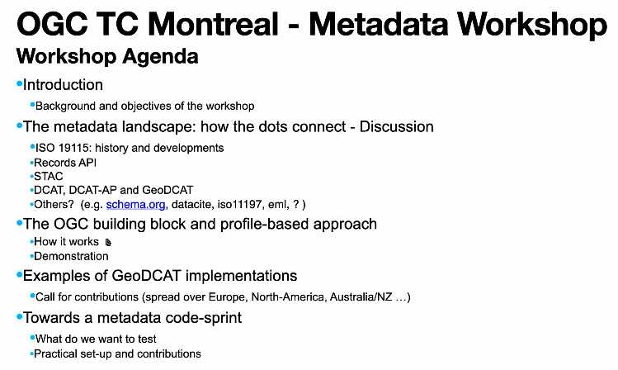

Danny will be at the meeting and will be able to chair.

WMO are also looking into the GeoCAT. RE: STAC implementation - Chris Little would be a good place to start to get a presentation. Also Mark McGoin (? MET office).

@ Others in the OGC are looking at this but we need to put in a call to the community to see what examples they have.

Rob A. Comments that STAC is not currently ideal – there are inconsistencies in the schema.

Chris L. says that STAC is about discoverability rather than cataloguing.

Still trying to line up a venue but the online portion will be supported by OGC.

AGENDA will fall out of the Montreal meeting. Byron is working with Chris Body on trying to get a physical venue.

@ Rob A. has been talking to a UNSW representative regarding a venue.

IEEE data provenance are working on the Indigenous Data Sovereignty. <https://standards.ieee.org/ieee/2890/10318/>

Peter Parslow 08:29 PM <https://www.gida-global.org/ieee-provenance>

Chris Little: The RDA Data Granularity WG that I mentioned has draft recommendations - very generic, but may be of interest. <https://docs.google.com/document/u/1/d/1IEFeL6Tp6z96-g_W4IlWL6HwTUQZPHpKATb4MYV9zcA>

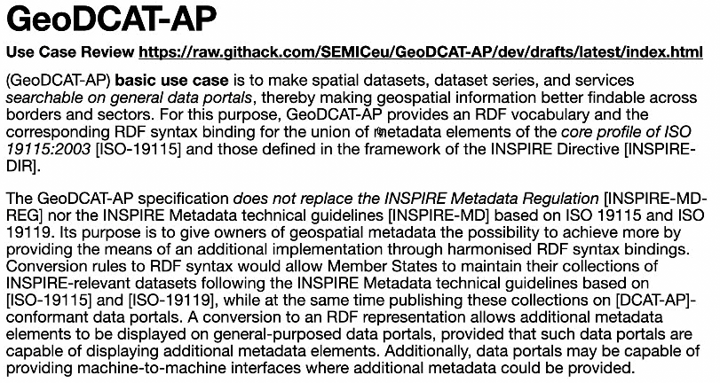

Uwe – comment. Conceptual model should be based more on the model of the 19115 where all the thinking about the spatial resolution etc have been done and tested over time. And think of GeoDCAT-AP as an RDF implementation of the XML.

Rob – I don’t see any conflict. Just accept the 19115 definitions etc that the community feel is relevant in the GeoDCAT to build the ontology. Then when another standard comes up then those required definitions can be brought up into GeoDCAT.

Rob – why would you change from 19115? Only if there was a technology stack change otherwise why bother.

Peter P. – align with the ISO19115-1 (conceptual encoding) beginning with the discovery core to align with the GeoDCAT-AP

Next pull in the Data Quality…

Uwe – what about the ISO19115-2? Answer – if we use ISO19115-3:2023 XML implementation it should be covered.

|> In GeoDCAT we would then need Sensors, Satellites, etc (earth observations)

Rob A. – we should take a modular approach and then you start with the core and then gradually add the EOS and other sectors – such as DataQual.

Glenn – asking Rob. What role do the connected systems standards take?   
Rob – We need to be systematic and start to the process of building out test cases and then see what happens when you take a record described by a bunch of standards and chose the best standard to map to/from – eg choose 19115 and model everything else to that.

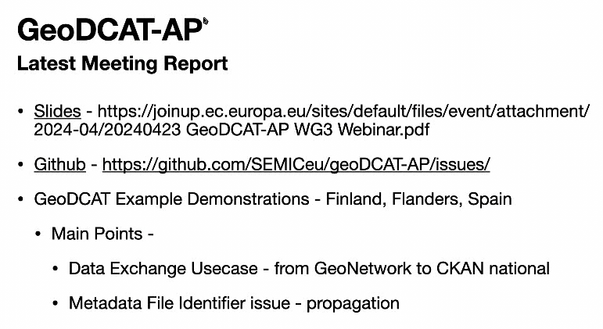

*RDA Plenary is coming up to endorse the 7 recommendations for archiving data – The WG on Data Granularity

Data Citation and dynamic data and … <https://www.rd-alliance.org/plenaries/data-granularity-guidance-final-outputs-their/>

MEETING ACTIONS

@ Byron to look for use case drivers – what our role is and how this group will progress

@ Danny to do the Montreal outreach – to see who else wants to attend the meeting and present

@ Rob to chase up the UNSW venue for the November code sprint

